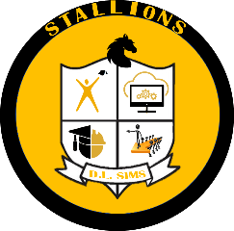
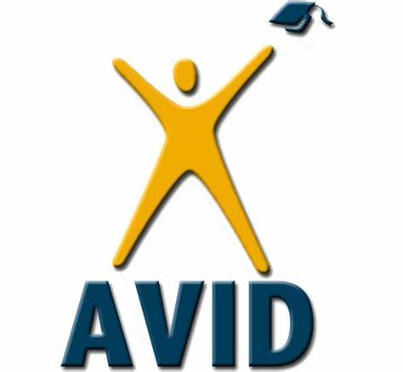
D.L. Sims Elementary School
~Achievement-Rigor-Growth-Consistency~
2023-2024
Theme: SES-Let’s Continue Growing Together
#KeepGrowing@dl_sims

Right to Know Notification

Date: August 28, 2023
Dear Parents,
In compliance with the requirements of the Every Students Succeeds Act, D.L. Sims would like to inform you that you may request information about the professional qualifications of your student’s teacher(s) and/ or paraprofessional(s). The following information may be requested:
- Whether the student’s teacher—
- has met State qualification and licensing criteria for the grade levels and subject areas in which the teacher provides instruction;
- is teaching under emergency or other provisional status through which State qualification or licensing criteria have been waived; and
- is teaching in the field of discipline of the certification of the teacher.

- Whether the child is provided services by paraprofessionals and, if so, their qualifications.

If you wish to request information concerning your child’s teacher’s and/or paraprofessional’s qualifications, please contact Ms. Shauntogris Johnson, at 770-922-0666.

Sincerely,
Shauntogris Johnson
Shauntogris Johnson
[Insert Principal/ LEA Designee Title]

